Apache Flink (For Data Engineering)
What is Apache Flink?
Apache Flink is a distributed stream processing framework used for real-time data processing at scale.
It is developed under the Apache Software Foundation.
Flink is designed for:
- Real-time stream processing
- Event-driven applications
- Stateful computations
- Low-latency analytics

Why Flink is Important in Data Engineering?
True Stream Processing Engine
Unlike micro-batching systems, Flink processes each event individually.
Stateful Processing
- Maintains application state (like counts, aggregations)
- Supports fault-tolerance with checkpoints
Exactly-Once Guarantee
Ensures no duplicate or lost data.
High Performance
Handles millions of events per second.

Where Flink is Used?
Commonly integrated with:
- Apache Kafka
- Apache Hadoop
- Apache Spark
- Apache Hive

Flink Architecture
Flink has two main components:
JobManager
- Manages job execution
- Coordinates checkpoints
- Schedules tasks
TaskManager
- Executes actual tasks
- Processes streams
- Stores state

Flink APIs
Flink provides:
API | Use Case
DataStream API | Real-time streaming
DataSet API | Batch processing
Table API | SQL-like operations
Flink SQL | Pure SQL queries

Batch vs Stream in Flink
Feature | Batch | Stream
Data Type | Finite | Infinite
Use Case | Historical data | Real-time events
Example | Daily report | Live transaction fraud detection
Flink unifies Batch + Stream.

Simple Example (Concept)
Scenario:
Real-time order processing system.
Kafka → Flink → Database / Dashboard
Flink:
- Reads order events
- Calculates total sales per minute
- Detects fraud patterns
- Writes results to DB

Key Concepts in Flink
1. Time Types
- Processing Time
- Event Time
- Ingestion Time
2. Windows
- Tumbling Window
- Sliding Window
- Session Window
Example:
Count orders every 1 minute.

3. Checkpointing
- Saves state periodically
- Recovers from failure

4. State Management
- Keyed State
- Operator State

Real Industry Use Cases
Banking
Fraud detection in real time

E-commerce
Live product recommendations

IoT
Sensor data analytics
Telecom
Network monitoring

Flink vs Spark Streaming
Feature | Flink | Spark Streaming
Processing Model | True Streaming | Micro-batch
Latency | Very Low | Medium
Stateful Support | Strong | Moderate
Exactly Once | Native | Supported

Interview Questions
Basic
- What is Apache Flink?
- Difference between Flink and Spark?
Intermediate
- What is Event Time?
- Explain Windowing in Flink.
- What is Checkpointing?
Advanced
- Explain Flink state backend.
- What is watermark?
- How does Flink ensure fault tolerance?

When to Use Flink?
Use Flink when you need:
Real-time processing
Low latency
Stateful streaming
Complex event processing
Fraud detection systems

If you want next, I can provide:
- Step-by-step Flink setup using Docker
- Flink + Kafka integration example
- Flink DataStream API code (Java/Scala)
- Flink SQL examples
- Complete Data Engineering module for Flink
Tell me your level (Beginner / Intermediate / Advanced)
Step-by-step Flink setup using Docker

Perfect Let’s set up Apache Flink using Docker step-by-step (Beginner Friendly + Data Engineering Focus).
We’ll run:
- Apache Flink
- Flink JobManager
- Flink TaskManager
- Flink Web UI

Architecture Overview

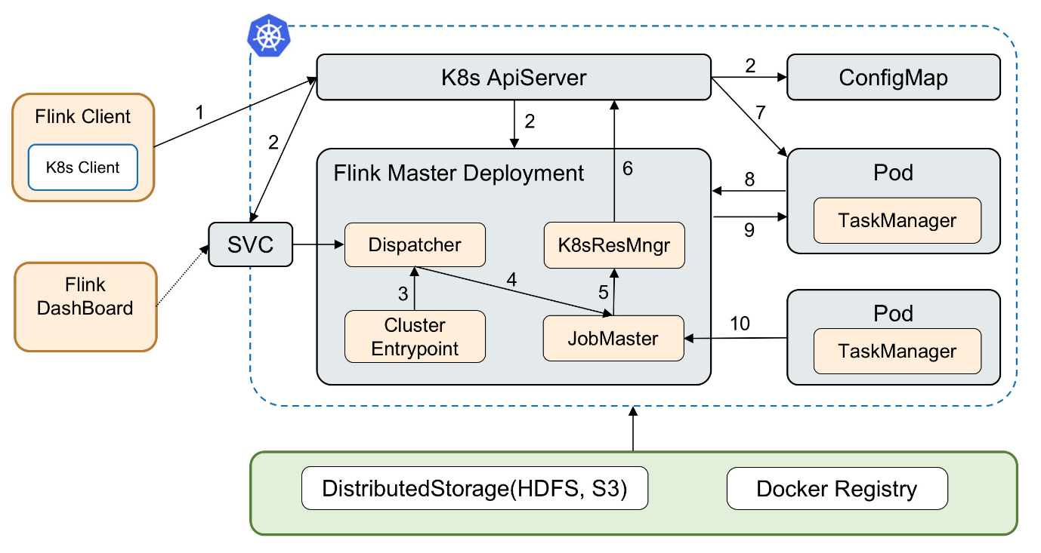

JobManager → Manages Jobs
TaskManager → Executes Tasks
Web UI → Monitor Jobs

Step 1: Install Docker
Verify:
docker --version
docker compose version
If not installed → Install Docker Desktop.

Step 2: Create Project Folder
mkdir flink-docker-demo
cd flink-docker-demo

Step 3: Create docker-compose.yml
docker-compose.yml

Paste this:

services:
jobmanager:
image: flink:latest
container_name: flink-jobmanager
ports:
- "8081:8081"
command: jobmanager
environment:
- |
FLINK_PROPERTIES=
jobmanager.rpc.address: jobmanager

taskmanager:
image: flink:latest
container_name: flink-taskmanager
depends_on:
- jobmanager
command: taskmanager
scale: 1
environment:
- |
FLINK_PROPERTIES=
jobmanager.rpc.address: jobmanager

Step 4: Start Flink Cluster
docker compose up -d
Check:
docker ps

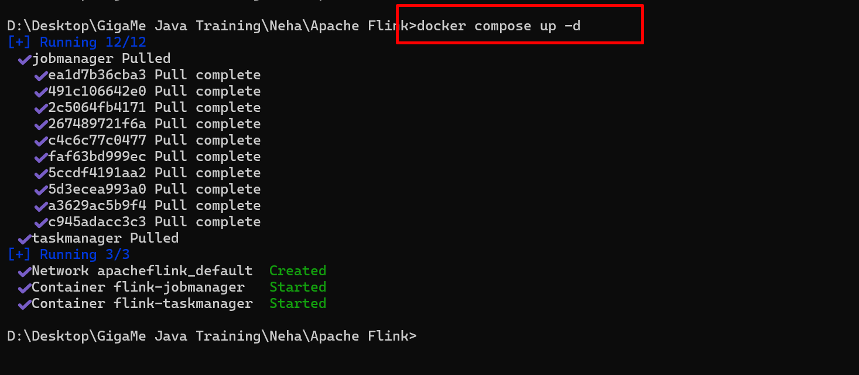
You should see:
- flink-jobmanager
- flink-taskmanager
- Step 5: Open Flink Web UI
- Open browser:
http://localhost:8081
You will see:
- Running TaskManagers
- Slots available
- Job submission section
Your Flink cluster is running!

Step 6: Run Sample WordCount Job
Enter JobManager container:
docker exec -it flink-jobmanager bash
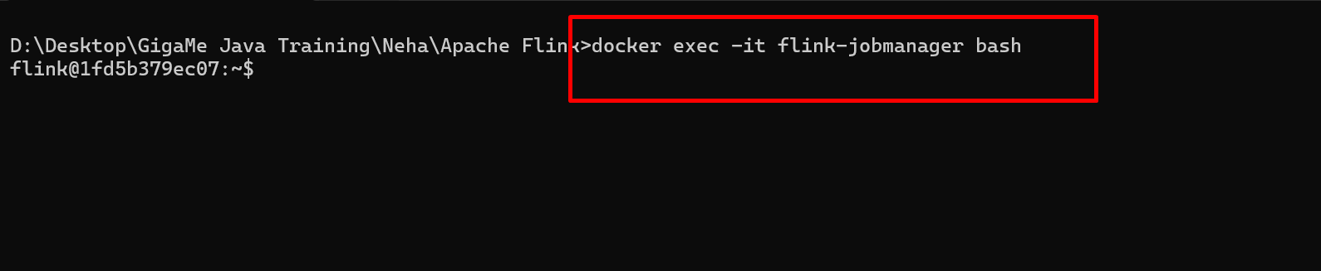

Verify few jobs core created using java with in the form jar file.

Run example:
flink run /opt/flink/examples/streaming/WordCount.jar

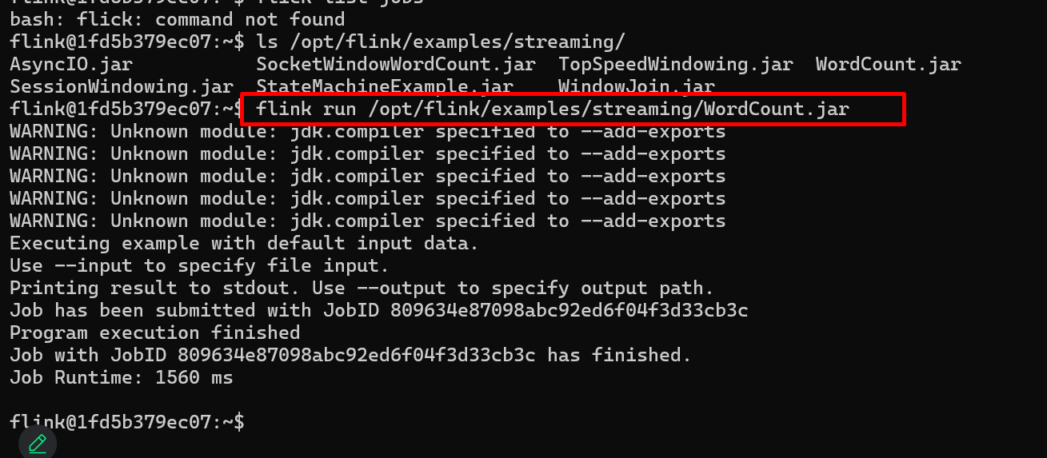

Now go to:
http://localhost:8081
You’ll see job execution graph.

Step 7: Check Logs (Optional)
Inside container:
cd log
ls
View logs:
cat flink-*-jobmanager-*.log

Step 8: Scale TaskManager (Cluster Mode)
Stop cluster:
docker compose down
Modify docker-compose:
deploy:
replicas: 2
OR run:
docker compose up --scale taskmanager=2 -d
Now refresh Web UI → You’ll see 2 TaskManagers.

Step 9: Stop Everything
docker compose down
Remove volumes:
docker compose down -v

Real Data Engineering Pipeline Example
Kafka → Flink → Database / Data Lake
Flink:
- Reads streaming events
- Applies transformation
- Aggregates using window
- Stores result

